**C2 Lab**

* Original email

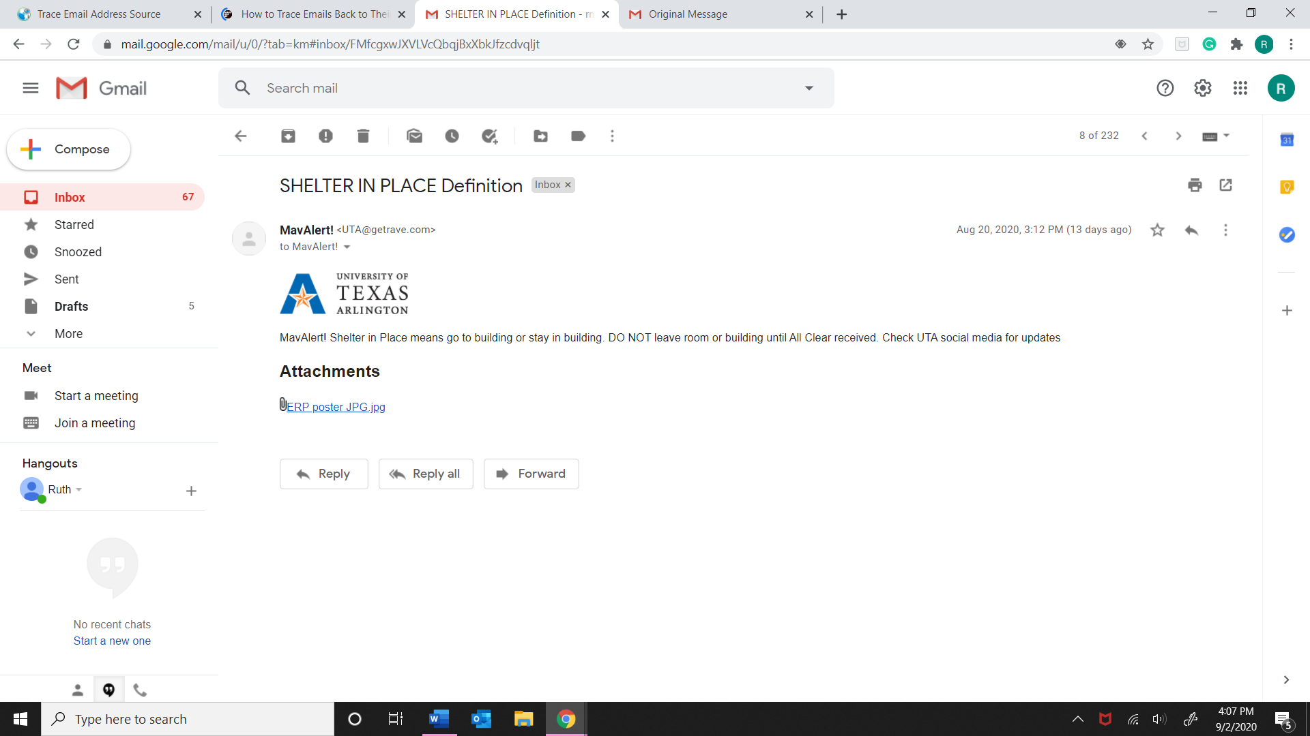

* Result I found when I clicked on “show original” in my Gmail.

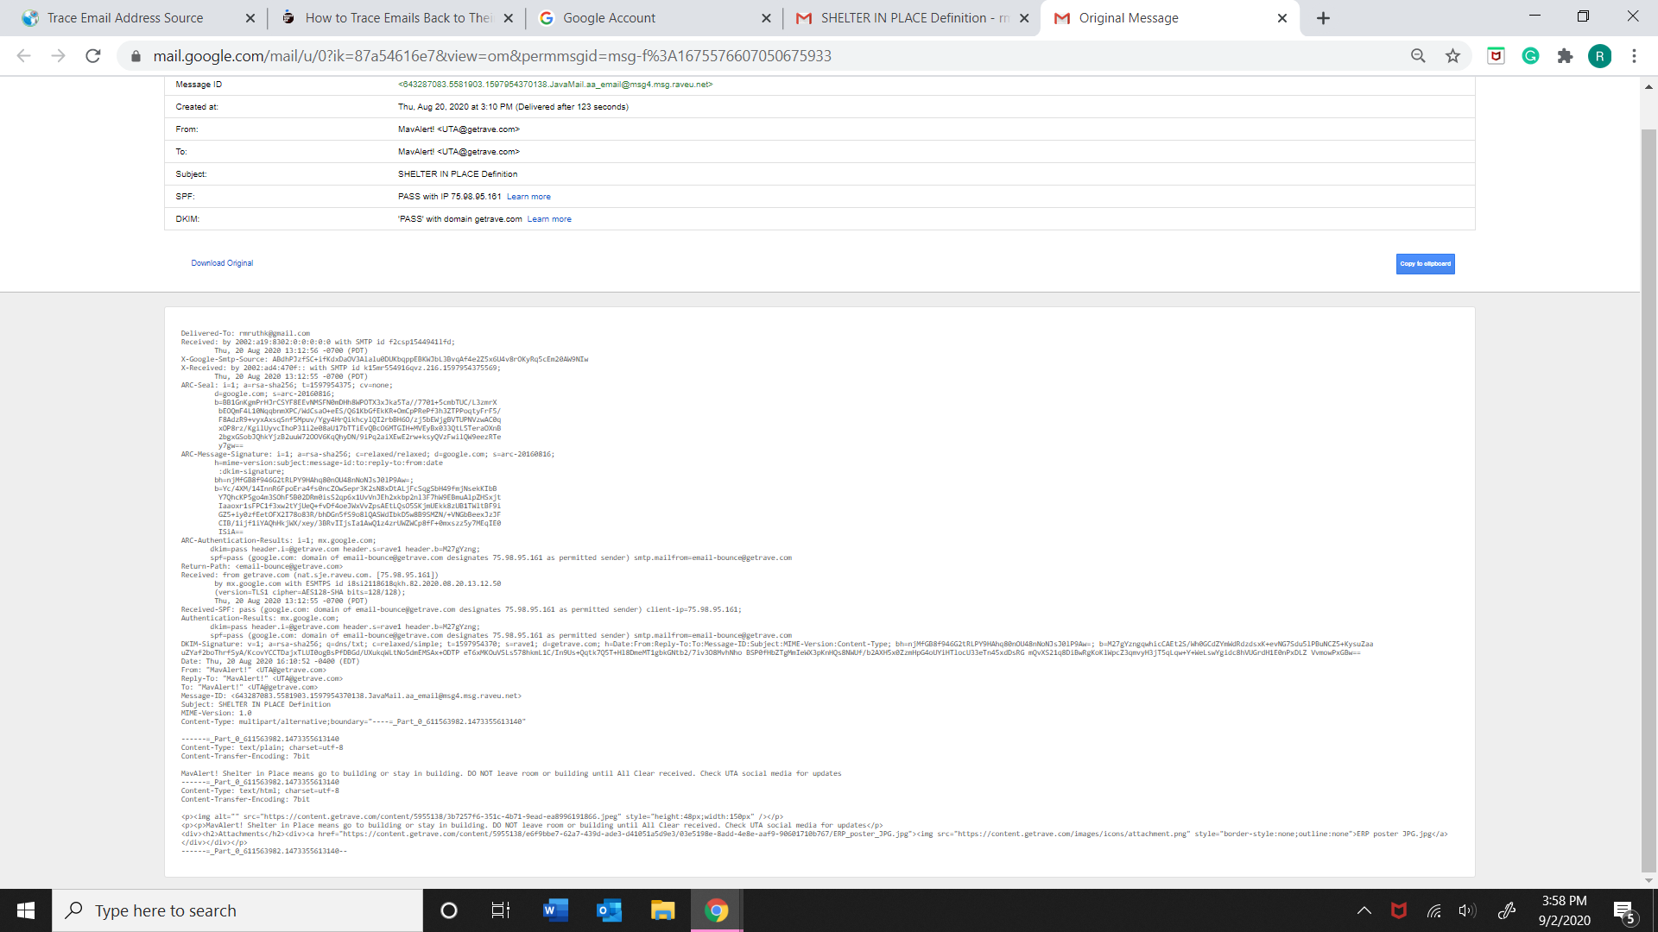

* Result when I paste header into Trace Email Analyzer

